Yan Geng

**DONG Xiwen (1914-1973)**

Dong Xiwen ((董希文) was a modern Chinese painter, whose art was widely appreciated in Communist China. Dong attended the National Academy of Arts in Hangzhou and in his early career, experimented with a diverse range of artistic styles, and demonstrated a great creative talent. His art underwent a radical change after the founding of the People’s Republic of China (PRC) in 1949. After moving to Beijing in the mid-1940s, Dong Xiwen began to make art in support of the Communist Party. He joined the Communist Party in 1949, and became one of the PRC’s most prominent painters, producing compelling paintings as part of state commissions whilst also teaching at the Central Academy of Fine Arts. His most famous commissioned work is *The Founding of the Nation*, commemorating the historical moment when Mao Zedong (毛泽东) proclaimed the People’s Republic of China atop of the Tiananmen gate in 1949. This painting was recognized as a model of new political art, not only articulating communist ideology but also acting an exemplar of nationalized oil painting. However, Dong later was forced to revise the painting twice, removing the disgraced figures from this monumental piece.

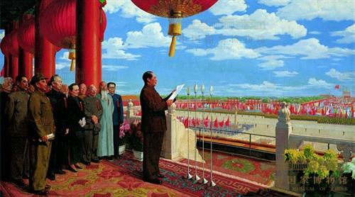

Dong Xiwen, *The Founding of China*, 1953, Oil on canvas, 230x405cm, National Museum of China

Dong was born in Shaoxing, Zhejiang Province, and learned traditional Chinese painting from the rich collection of his father Dong Eqing (董萼清), who was a renowned art collector and enthusiastic of Chinese antiquity. When studying at the Hangzhou academy, he was fascinated with the artworks of European masters, which led to his reconsideration of traditional Chinese pictorial language. In 1930s, he studied at the National Academy of Fine Arts in Hangzhou, headed by the French-trained artist Lin Fengmian (林风眠). Taking the French curriculum as its model, the Hangzhou academy set its mission to educate a new generation of artists and to create modern Chinese art by synthesizing indigenous tradition and Western culture. After graduation, Dong traveled to Dunhuang and spent two and half years there on copying and exploring the ancient murals preserved in Buddhist cave temples.

Dong Xiwen’s art career was curtailed by illness. He died of cancer during the Cultural Revolution (1966-1976). Yet along with his other paintings, *The Founding of the Nation* is now displayed in the center of an exhibiting hall in the National Museum in Beijing, together with a restored copy of its original version.

**List of works**

Dong, X. (1958) *Changzheng lushang xiesheng ji (Colleciton of sketches along the route of the Long March)*, Beijing: Renmin meishu chubanshe.

Dong, X. (1996) *Dong Xiwen Huaji (Collection of Dong Xiwen’s Paintings)*, Beijing: Renmin meishu chubanshe.

Beijing huayuan ed. (2009) *Guofeng jingjie: Dong Xiwen huaji* (*The Realm of National Style: Collection of Dong Xiwen’s Paintings*), Beijing: Wenhua yishu chubanshe.

**References and further reading**

Andrews, J. (1994) *Painters and Politics in the People’s Republic of China, 1949-1979*, Berkeley: University of California Press.

Gong, C. (2001) *Dong Xiwen*. Nanning: Guangxi meishu chubanshe.

Zhou, G. (2008) *Youhua minzuhua: Dong Xiwen de lilun yu shijian yanji*u (*Nationalizing Oil Painting: Study of Dong Xiwen’s Theory and Practice*), Changsha: Hunan renmin chubanshe.